NAME: ARYAN ARUN
REG.NO: 192411157
COURSE: CSA1303 THEORY OF COMPUTATION
LAB EXPERIMENT 1-5

EXPERIMENT 1:
#include <stdio.h>
#include <string.h>

int main() {
char str[100];

printf("Enter string: ");
scanf("%s", str);

if (str[0] == 'a' && str[strlen(str) - 1] == 'a')
printf("String Accepted");
else
printf("String Rejected");

return 0;
}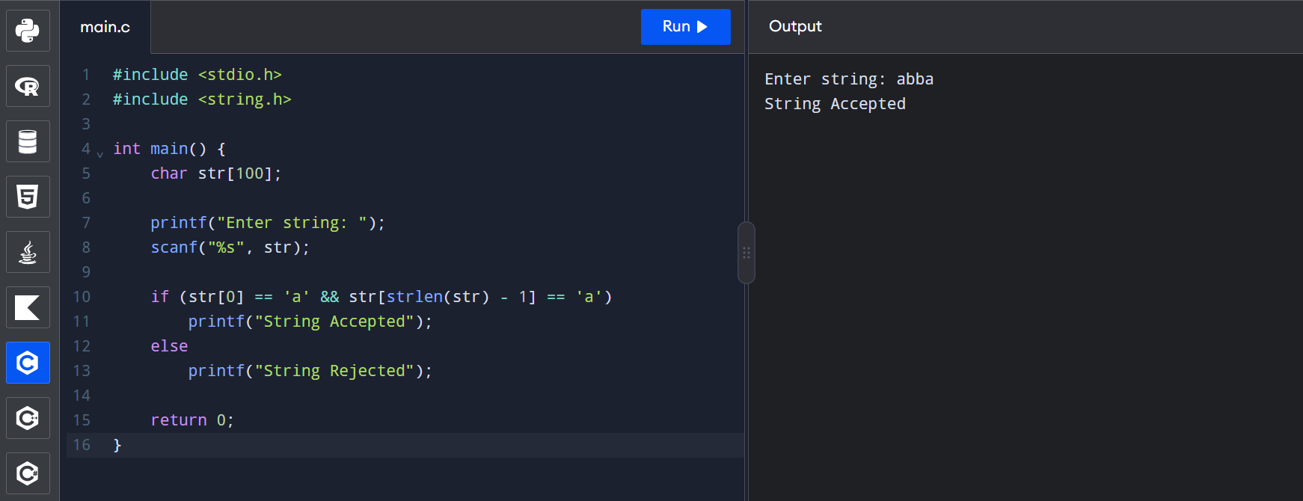

EXPERIMENT 2:
#include <stdio.h>
#include <string.h>

int main() {
char str[100];

printf("Enter string: ");
scanf("%s", str);

if (str[0] == '0' && str[strlen(str) - 1] == '1')
printf("String Accepted");
else
printf("String Rejected");

return 0;
}
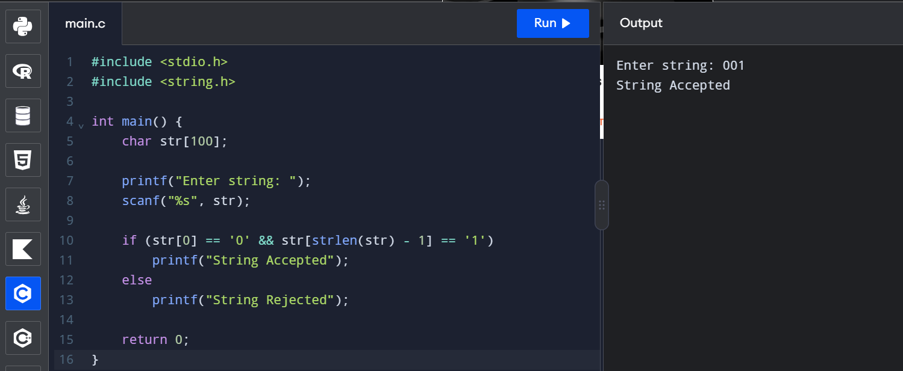

EXPERIMENT 3:
#include <stdio.h>
#include <string.h>

int main() {
char str[100];

printf("Enter a string: ");
scanf("%s", str);

int n = strlen(str);

if (n >= 2 && str[0] == '0' && str[n - 1] == '1')
printf("String Accepted");
else
printf("String Rejected");

return 0;
}
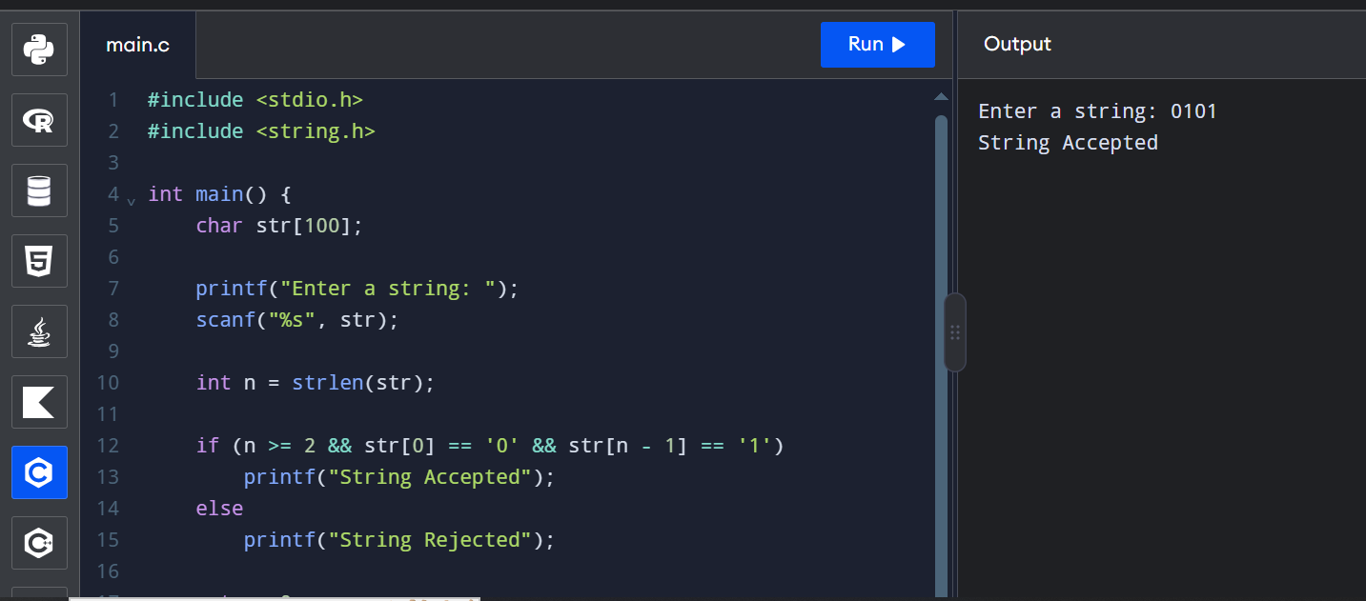
EXPERIMENT 4:
#include <stdio.h>
#include <string.h>
int main() {
char str[100];
int i, j, flag = 1;
printf("Enter a string: ");
scanf("%s", str);
i = 0;
j = strlen(str) - 1;
while (i < j) {
if (str[i] != str[j]) {
flag = 0;
break;
}
i++;
j--;
}
if (flag)
printf("String Accepted");
else
printf("String Rejected");
return 0;
}
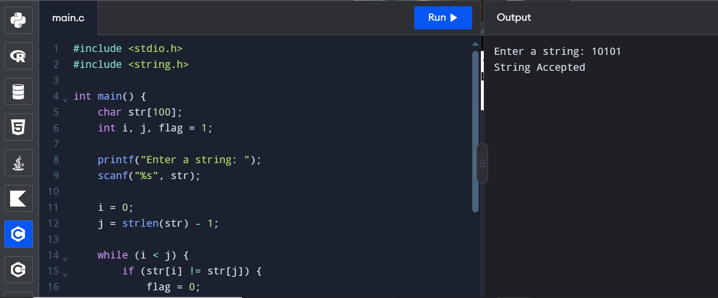

EXPERIMENT 5:
#include <stdio.h>
#include <string.h>

int main() {
char str[100];
int i = 0, j, flag = 1;

printf("Enter a string: ");
scanf("%s", str);

j = strlen(str) - 1;

while (i < j && str[i] == '0' && str[j] == '0') {
i++;
j--;
}

while (i <= j) {
if (str[i] != '1') {
flag = 0;
break;
}
i++;
}

if (flag)
printf("String Accepted");
else
printf("String Rejected");

return 0;
}

